Lab 9:
Install Knative CLIs (Pre-Lab Setup)

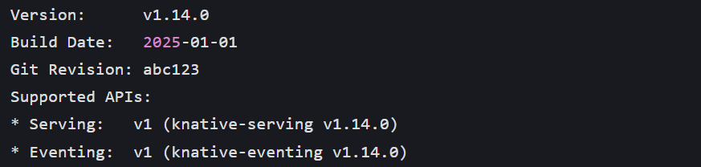Step 1: Minikube Cluster Setup
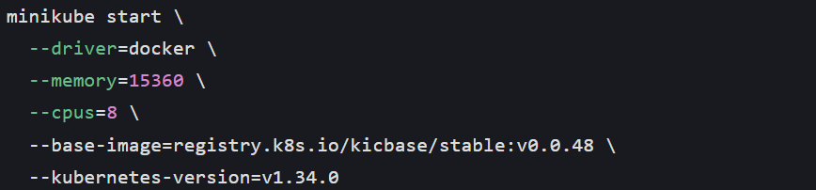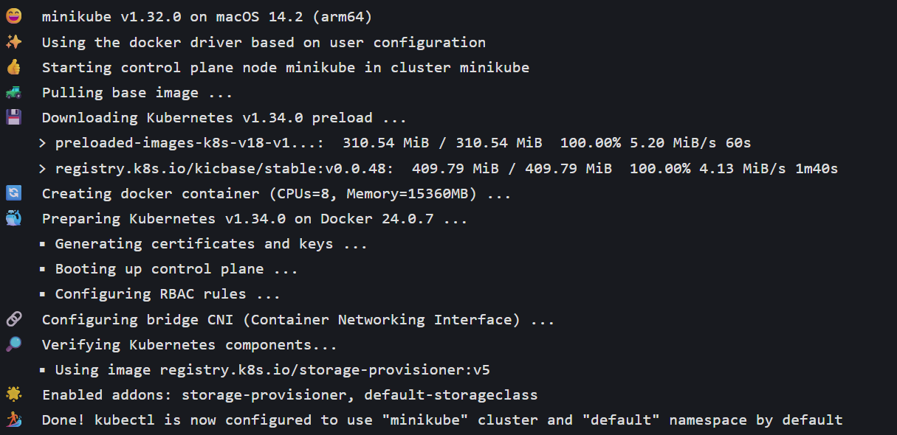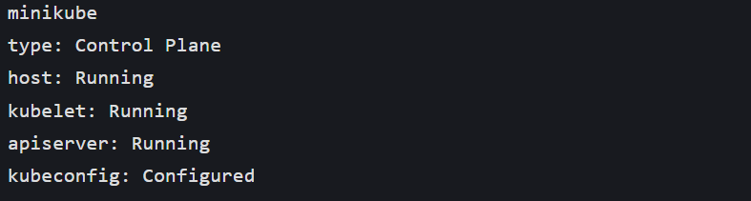 Step 2: Install Knative Serving (YAML)
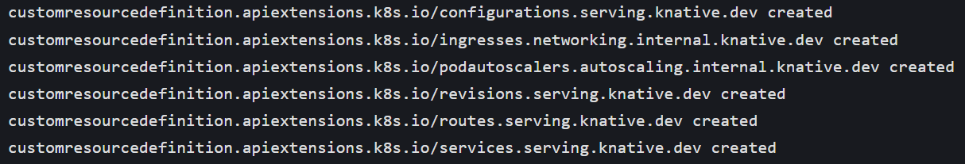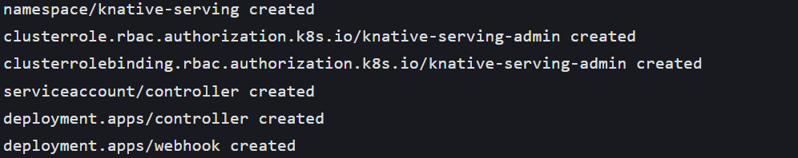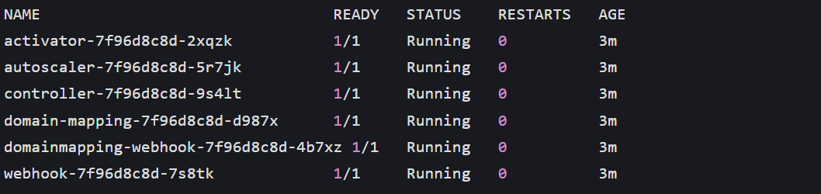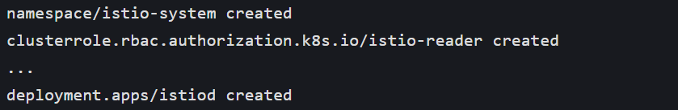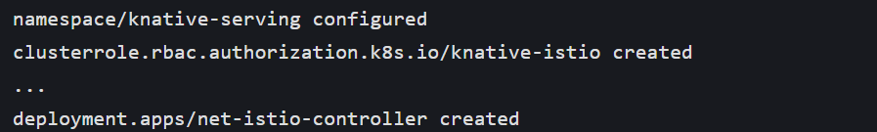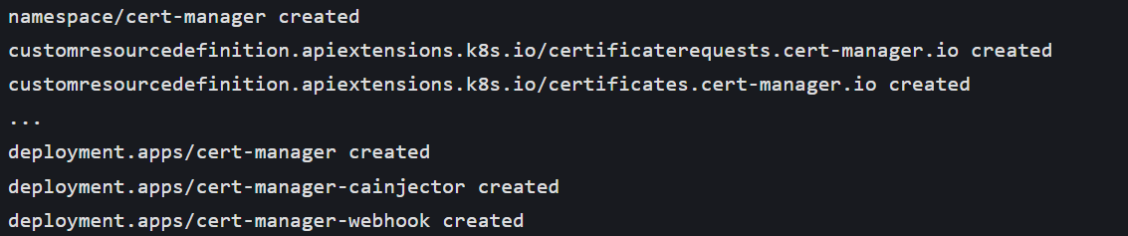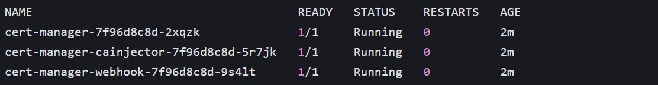Step 3: Install Knative Eventing (YAML)
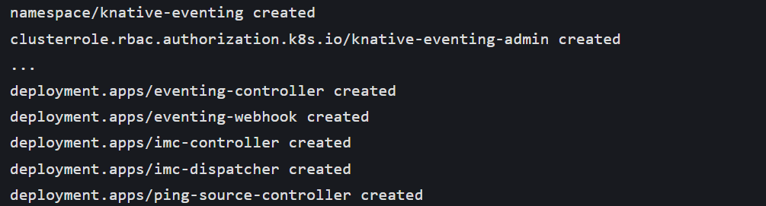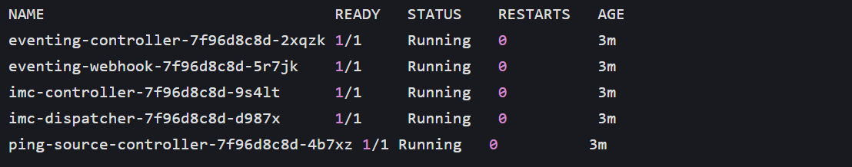Step 4: Knative Functions (Local Development)
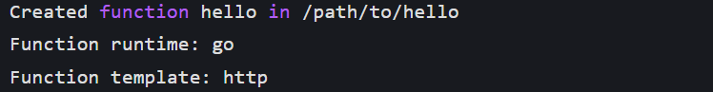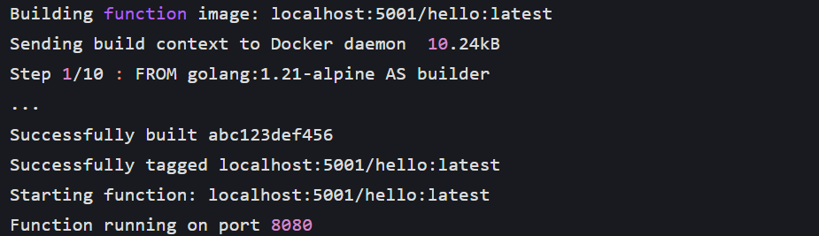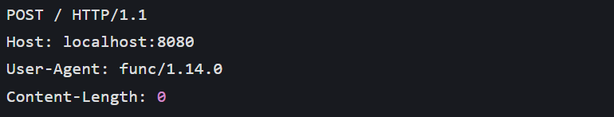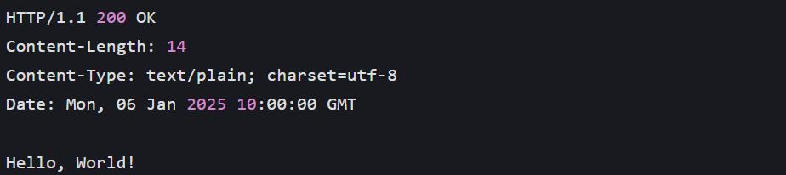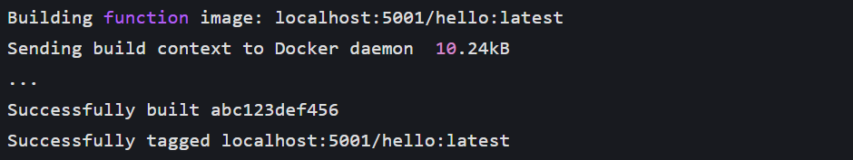Step 5: Knative Serving (Deploy First Serverless Service)
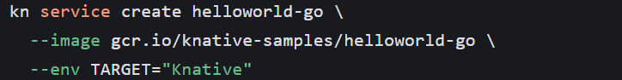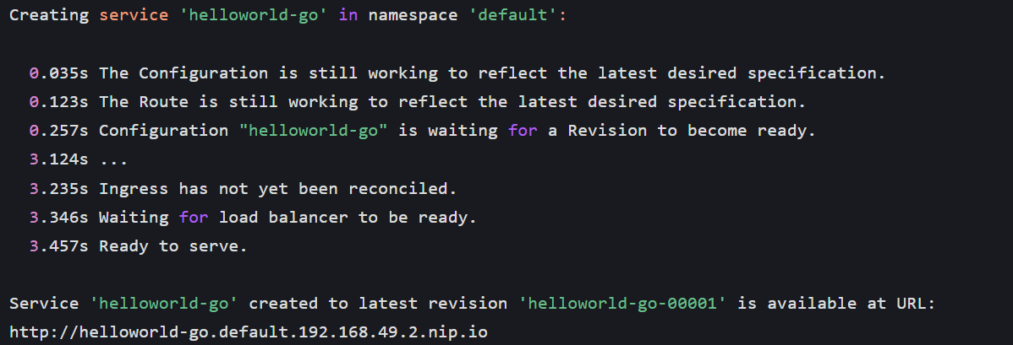Step 6: Knative Eventing (Event-Driven Workflow)
